Diagnosis

This section of the Cancer Trends Progress Report - 2005 Update provides data on the rates of new cancers, based on the NCI Surveillance, Epidemiology, and End-Results (SEER) Program, by cancer site and by racial and ethnic group. Also included are data on the proportion of cancers diagnosed at a late stage for five of the major cancer sites where cancer screening has been shown or has been evaluated to make a difference in outcomes. Cancer sites include: female breast, colon, rectum, cervix, and prostate.
Source: www.cancer.gov

Cancer: Choosing a Treatment Program
What are the different kinds of cancer treatment?
Source: http://familydoctor.org

Statistics

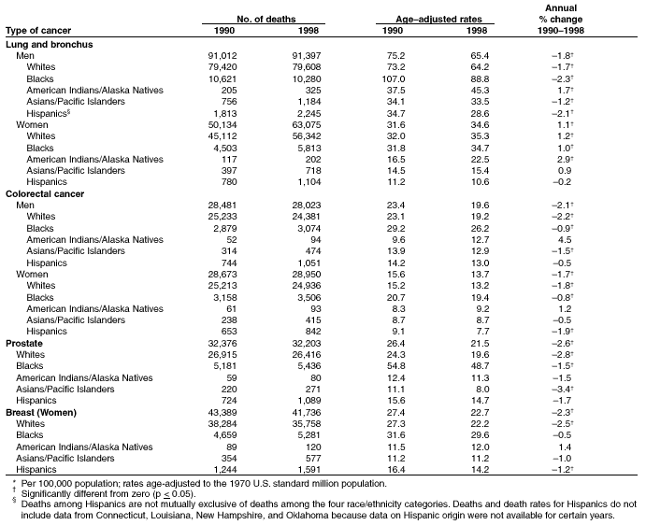

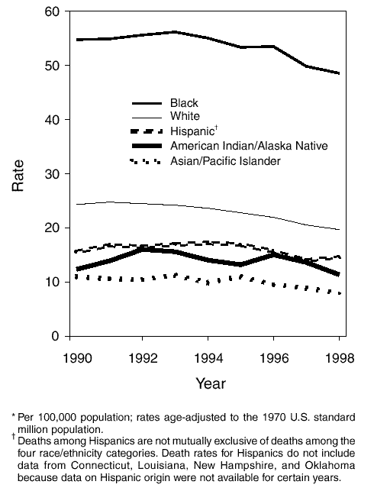

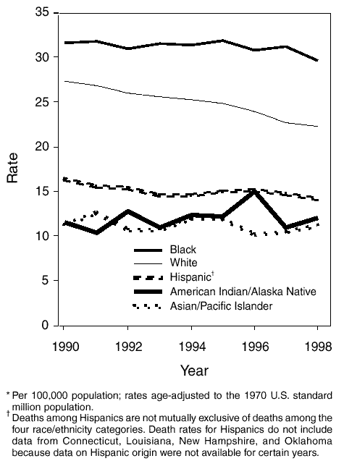

Tobacco and Cancer
Smoking damages nearly every organ in the human body, is linked to at least 10 different cancers, and accounts for some 30% of all cancer deaths. And it costs billions of dollars each year. Yet one in four Americans still light up. If you or someone you love uses tobacco, here's what you need to know about how tobacco kills, and how to get the help you need to quit.

Sun Safety

A sunburn will fade, but damage to deeper layers of skin remains and can eventually cause cancer. That's why sun-safe habits should begin in childhood and last a lifetime.

Food and Fitness

Eating right, being active, and maintaining a healthy weight are important ways to reduce your risk of cancer—as well as heart disease and diabetes. Learn the American Cancer Society's guidelines for diet and activity and find tips for a healthy lifestyle and community.

Early Detection

If you can't prevent cancer, the next best thing you can do to protect your health is to detect it early. Recognizing symptoms, getting regular check-ups, and performing self-exams are just a few ways you can do this.

Source: www.cancer.org

